**1.Problem Statement:**  
Enlist all the employees ID's, names along with the Project allocated to them.

**Information about the table:**  
Table **Employee:** 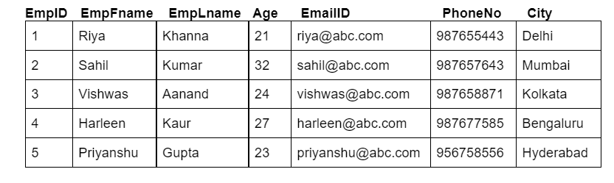  
Table **Project:** 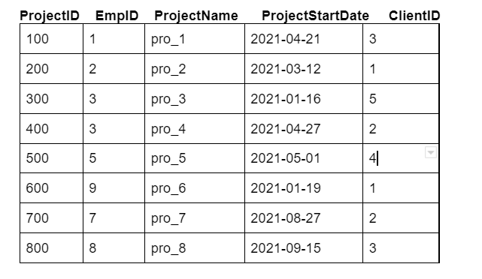  
Table **Client_d:** 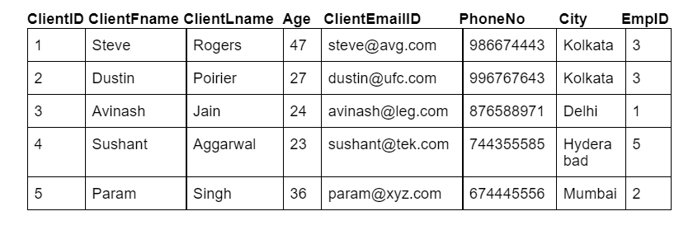

**Output Table Structure:**  


Note-1: Write keywords of syntax in uppercase alphabets.

Note-2: Use employee ID to link the two tables.

**ANSWER:**

**Select Employee.EmpID , Employee.EmpFname,Employee.EmpLname,Project.ProjectID,Project.ProjectName from Employee inner join Project on**

**Employee.EmpID = Project.EmpID ;**

+-------+-----------+----------+-----------+-------------+

| EmpID | EmpFname | EmpLname | ProjectID | ProjectName |

+-------+-----------+----------+-----------+-------------+

| 1 | Riya | Khanna | 100 | pro_1 |

| 2 | Sahil | Kumar | 200 | pro_2 |

| 3 | Vishwas | Aanand | 300 | pro_3 |

| 3 | Vishwas | Aanand | 400 | pro_4 |

| 5 | Priyanshu | Gupta | 500 | pro_5 |

+-------+-----------+----------+-----------+-------------+

**2.Problem Statement:**  
Fetch out all the employee ID’s and their contact detail who have been working from Delhi or have clients in Kolkata.

**Information about the table:**  
Table **Employee:**   
Table **Project:** 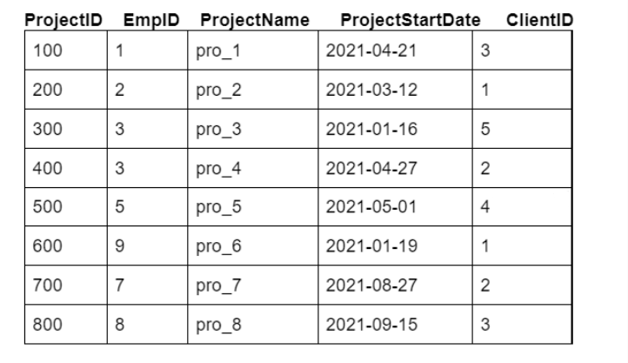  
Table **Client_d:** 

**Output Table Structure:**  


Note-1: Write keywords of syntax in uppercase alphabets.

Note-2: Use employee ID to link the two tables.

**ANSWER:**

**SELECT Employee.EmpID ,Employee.EmailID , Employee.PhoneNo , Client_d.ClientFname , Client_d.ClientLname**

**FROM Employee INNER JOIN Client_d ON Employee.EmpID = Client_d.EmpID**

**WHERE employee.City = 'Delhi' or Client_d.City = 'Kolkata' ;**

+-------+-----------------+-----------+-------------+-------------+

| EmpID | EmailID | PhoneNo | ClientFname | ClientLname |

+-------+-----------------+-----------+-------------+-------------+

| 3 | vishwas@abc.com | 987658871 | Steve | Rogers |

| 3 | vishwas@abc.com | 987658871 | Dustin | Poirier |

| 1 | riya@abc.com | 987655443 | Avinash | Jain |

+-------+-----------------+-----------+-------------+-------------+

**3.Problem Statement:**  
List out all the project names with corresponding client’s email id, for all the projects that were allocated after April 2021 and order them in descending order of the age of clients.

**Information about the table:**  
Table **Employee:**   
Table **Project:**   
Table **Client_d:** 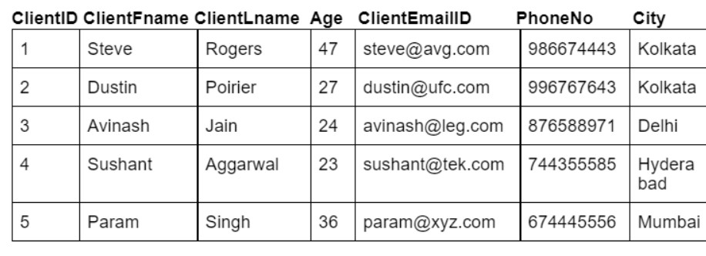

**Output Table Structure:**  


Note-1: Write keywords of syntax in uppercase alphabets.

Note-2: Use client ID to link the two tables.

**ANSWER:**

**SELECT Project.ProjectName, Client_d.ClientEmailID**

**FROM Project**

**INNER JOIN Client_d ON Client_d.ClientID=Project.ClientID**

**Where Project.ProjectStartDate > '2021-04-30'**

**Order By Client_d.Age DESC;**

+-------------+-----------------+

| ProjectName | ClientEmailID |

+-------------+-----------------+

| pro_7 | dustin@ufc.com |

| pro_8 | avinash@leg.com |

| pro_5 | sushant@tek.com |

+-------------+-----------------+

**4.Problem Statement:**  
Fetch out each project allocated to which employee.

**Information about the table:**  
Table **Employee:**   
Table **Project:**   
Table **Client_d:** 

**Output Table Structure:**  


Note-1: Write keywords of syntax in uppercase alphabets.

Note-2: Use employee ID to link the two tables.

**ANSWER:**

**SELECT Employee.EmpFname,Employee.EmpLname , Project.ProjectID, Project.ProjectName**

**FROM Employee**

**Left JOIN Project ON Employee.EmpID=Project.EmpID;**

+-----------+----------+-----------+-------------+

| EmpFname | EmpLname | ProjectID | ProjectName |

+-----------+----------+-----------+-------------+

| Riya | Khanna | 100 | pro_1 |

| Sahil | Kumar | 200 | pro_2 |

| Vishwas | Aanand | 400 | pro_4 |

| Vishwas | Aanand | 300 | pro_3 |

| Harleen | Kaur | NULL | NULL |

| Priyanshu | Gupta | 500 | pro_5 |

+-----------+----------+-----------+-------------+

**5.Problem Statement:**  
List out all the projects along with the employee's name and their respective allocated email ID.

**Information about the table:**  
Table **Employee:**   
Table **Project:**   
Table **Client_d:** 

**Output Table Structure:**  


Note-1: Write keywords of syntax in uppercase alphabets.

Note-2: Use employee ID to link the two tables.

**ANSWER:**

**SELECT Project.ProjectID,Project.ProjectName,Employee.EmpFname,Employee.EmpLname,Employee.EmailID**

**FROM Employee**

**Right JOIN Project ON Employee.EmpID=Project.EmpID;**

+-----------+-------------+-----------+----------+-------------------+

| ProjectID | ProjectName | EmpFname | EmpLname | EmailID |

+-----------+-------------+-----------+----------+-------------------+

| 100 | pro_1 | Riya | Khanna | riya@abc.com |

| 200 | pro_2 | Sahil | Kumar | sahil@abc.com |

| 300 | pro_3 | Vishwas | Aanand | vishwas@abc.com |

| 400 | pro_4 | Vishwas | Aanand | vishwas@abc.com |

| 500 | pro_5 | Priyanshu | Gupta | priyanshu@abc.com |

| 600 | pro_6 | NULL | NULL | NULL |

| 700 | pro_7 | NULL | NULL | NULL |

| 800 | pro_8 | NULL | NULL | NULL |

+-----------+-------------+-----------+----------+-------------------+

**6.Problem Statement:**  
List out all the client details email address, whose age is between 25 to 35, along with the projects assigned to them in ascending order of their age and project ID. Also, use c for client_d and p for project, as alias name of tables.

**Information about the table:**  
Table **Employee:**   
Table **Project:**   
Table **Client_d:** 

**Output Table Structure:**  


Note-1: Write keywords of syntax in uppercase alphabets.

Note-2: Use client ID to link the two tables.

**ANSWER:**

**SELECT c.ClientID, c.ClientFname, c.ClientLname, c.ClientEmailID,p.ProjectID, p.ProjectName**

**FROM Client_d As c**

**Join Project As p ON c.ClientID=p.ClientID**

**where c.Age Between 25 And 35**

**Order By p.ProjectID ASC;**

+----------+-------------+-------------+----------------+-----------+-------------+

| ClientID | ClientFname | ClientLname | ClientEmailID | ProjectID | ProjectName |

+----------+-------------+-------------+----------------+-----------+-------------+

| 2 | Dustin | Poirier | dustin@ufc.com | 400 | pro_4 |

| 2 | Dustin | Poirier | dustin@ufc.com | 700 | pro_7 |

+----------+-------------+-------------+----------------+-----------+-------------+